**Lab Assignment 2.1**

**AP21110010302**

**Krish Srivastava**

**CSE – E  
Network Security – CSE 315L**

1. **Perform basic Nmap Scan against IP or host**

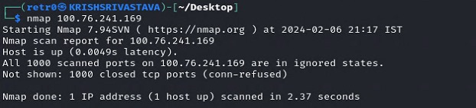

1. **Scan specific ports or scan entire port ranges on a local or remote server**

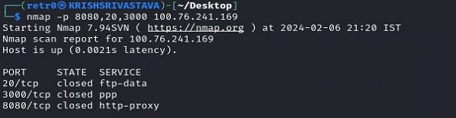

1. **Scan multiple IP addresses**

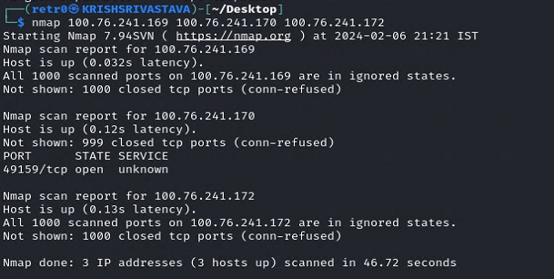

1. **Scan IP ranges**

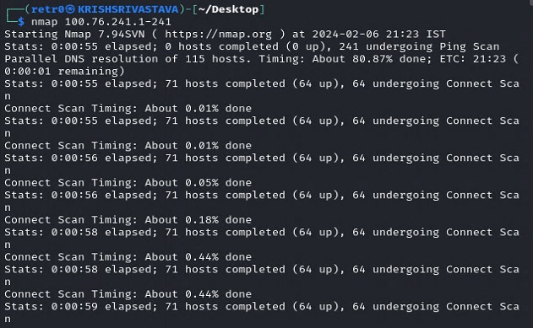

1. **Scan the most popular ports**

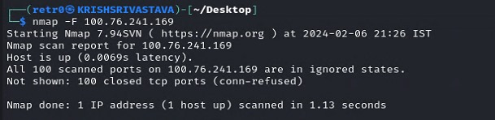

1. **Scan hosts and IP addresses reading from a text file**

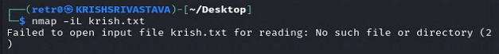

1. **Save your Nmap scan results to a file**

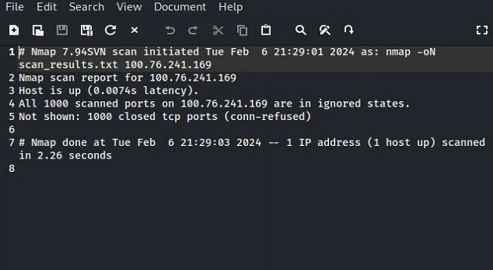

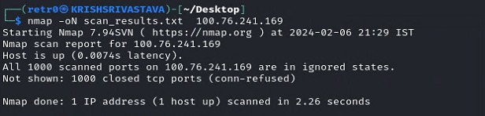

1. **Disabling DNS name resolution**

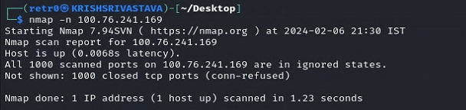

1. **Scan + OS and service detection with fast execution**

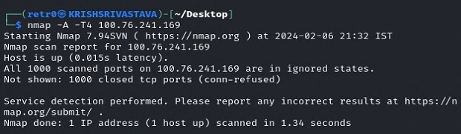

1. **Detect service/daemon versions**

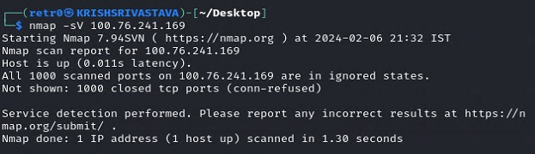

1. **Scan using TCP or UDP protocols**

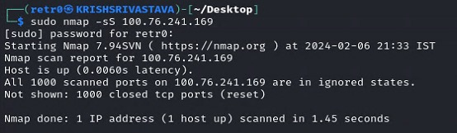

1. **CVE detection using Nmap Scripting Engine**

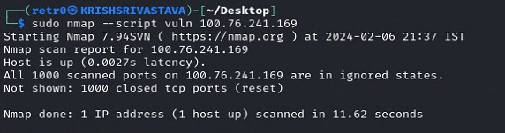

1. **Launching DOS with Nmap**

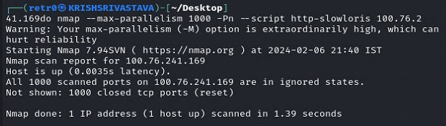

1. **Launching DOS with Nmap**

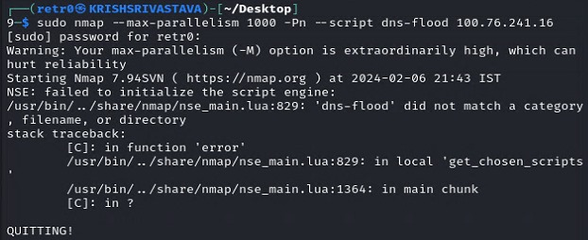

1. **Detecting malware infections on remote hostss**

